Non-Uniform Polyhedron

Definition
# Source: AI Source: Provided by: [Data Path: Persons Table -> ID Column: 1, Name_En Column: Motasem Essam] -> From: [ChatGPT] on [7/25/2026]
A Non-Uniform Polyhedron is a polyhedron that does not satisfy all the requirements of a uniform polyhedron.
A polyhedron is non-uniform if its faces are not all regular polygons, its vertices are not all geometrically equivalent under the symmetry group, or both.
Unlike uniform polyhedra, non-uniform polyhedra do not require every vertex to have the same arrangement of faces. They may have different face shapes, different edge lengths, and different vertex configurations.
Important: Non-uniform polyhedron is a broad descriptive classification, rather than a single standardized family with a fixed number of members.

Geometric Structure
# Source: AI Source: Provided by: [Data Path: Persons Table -> ID Column: 1, Name_En Column: Motasem Essam] -> From: [ChatGPT] on [7/25/2026]
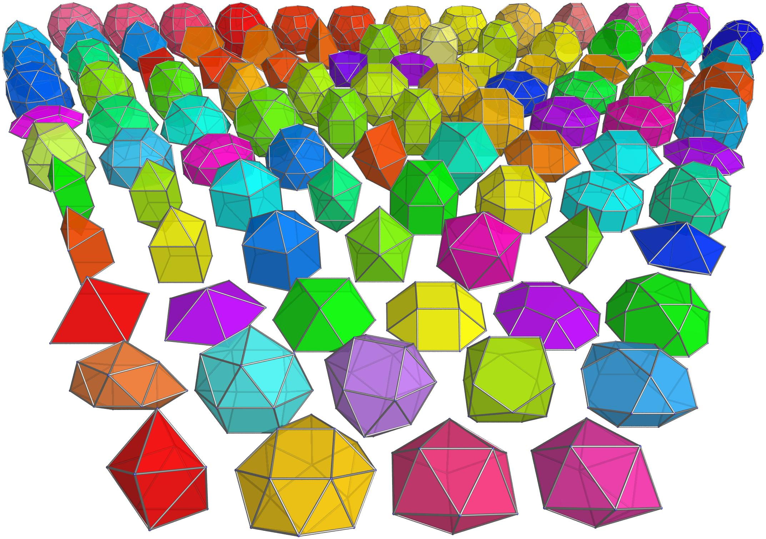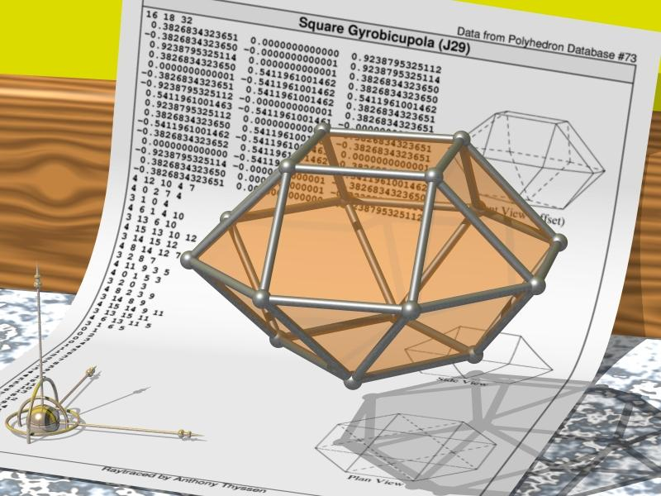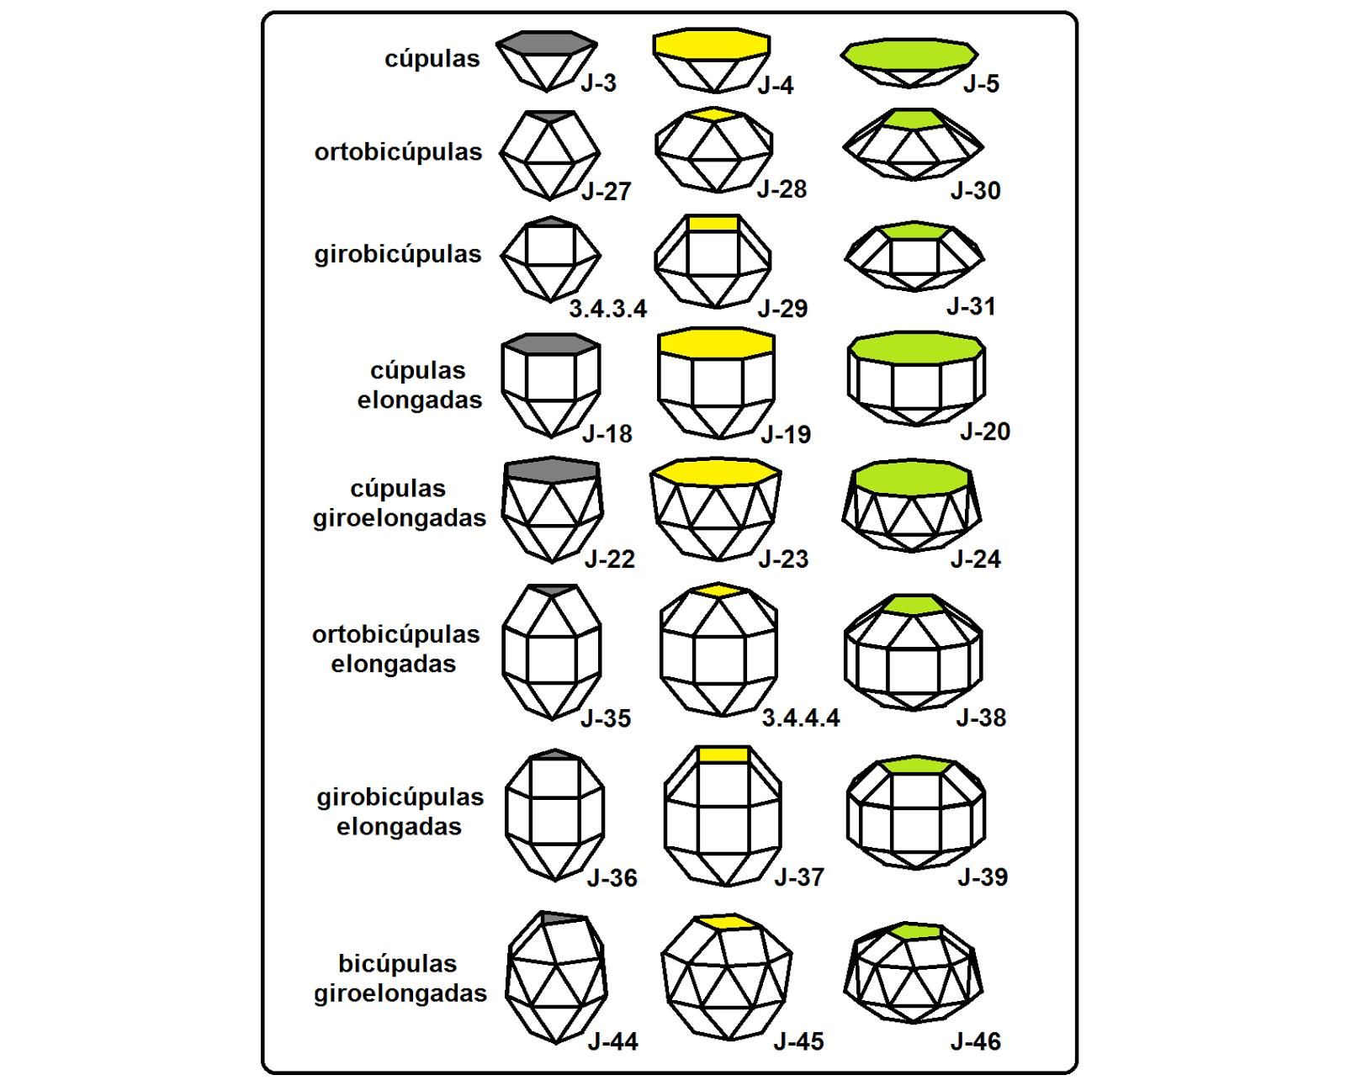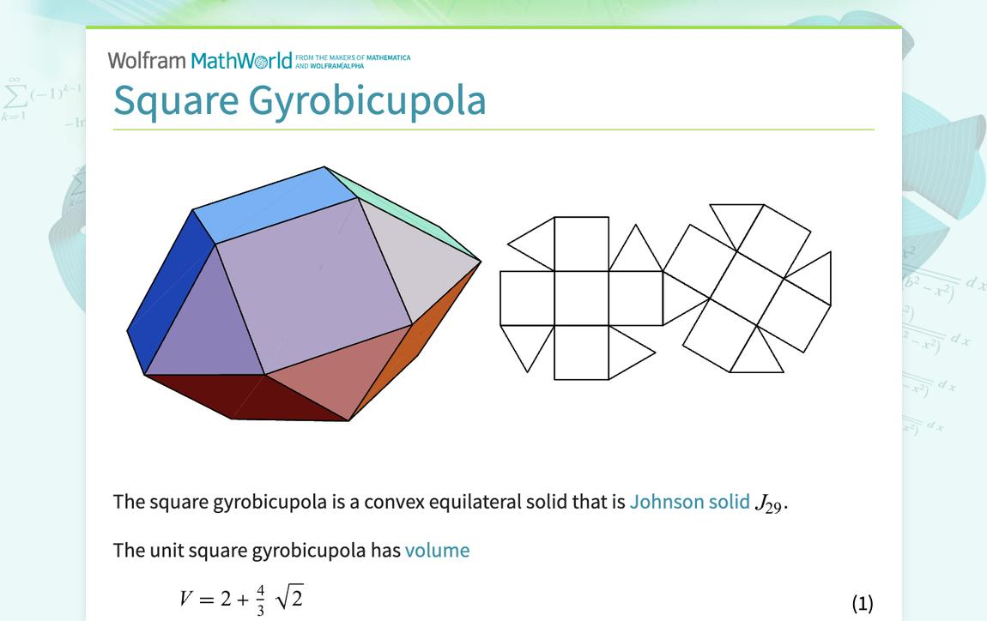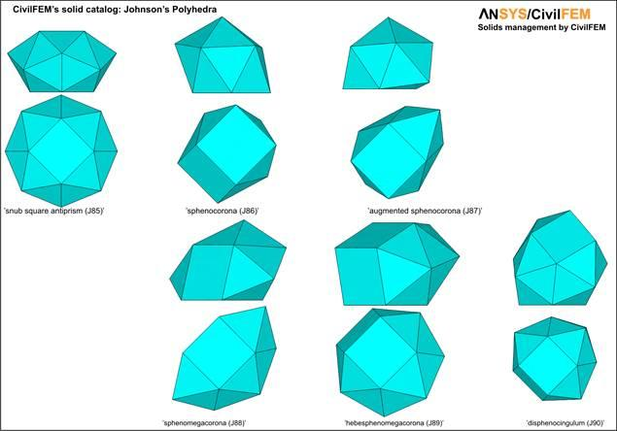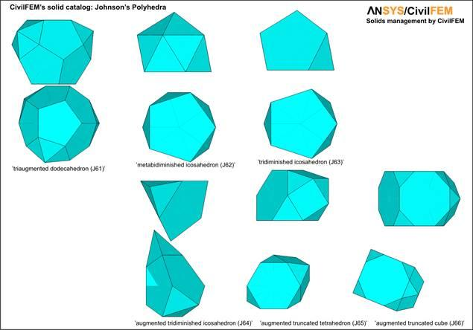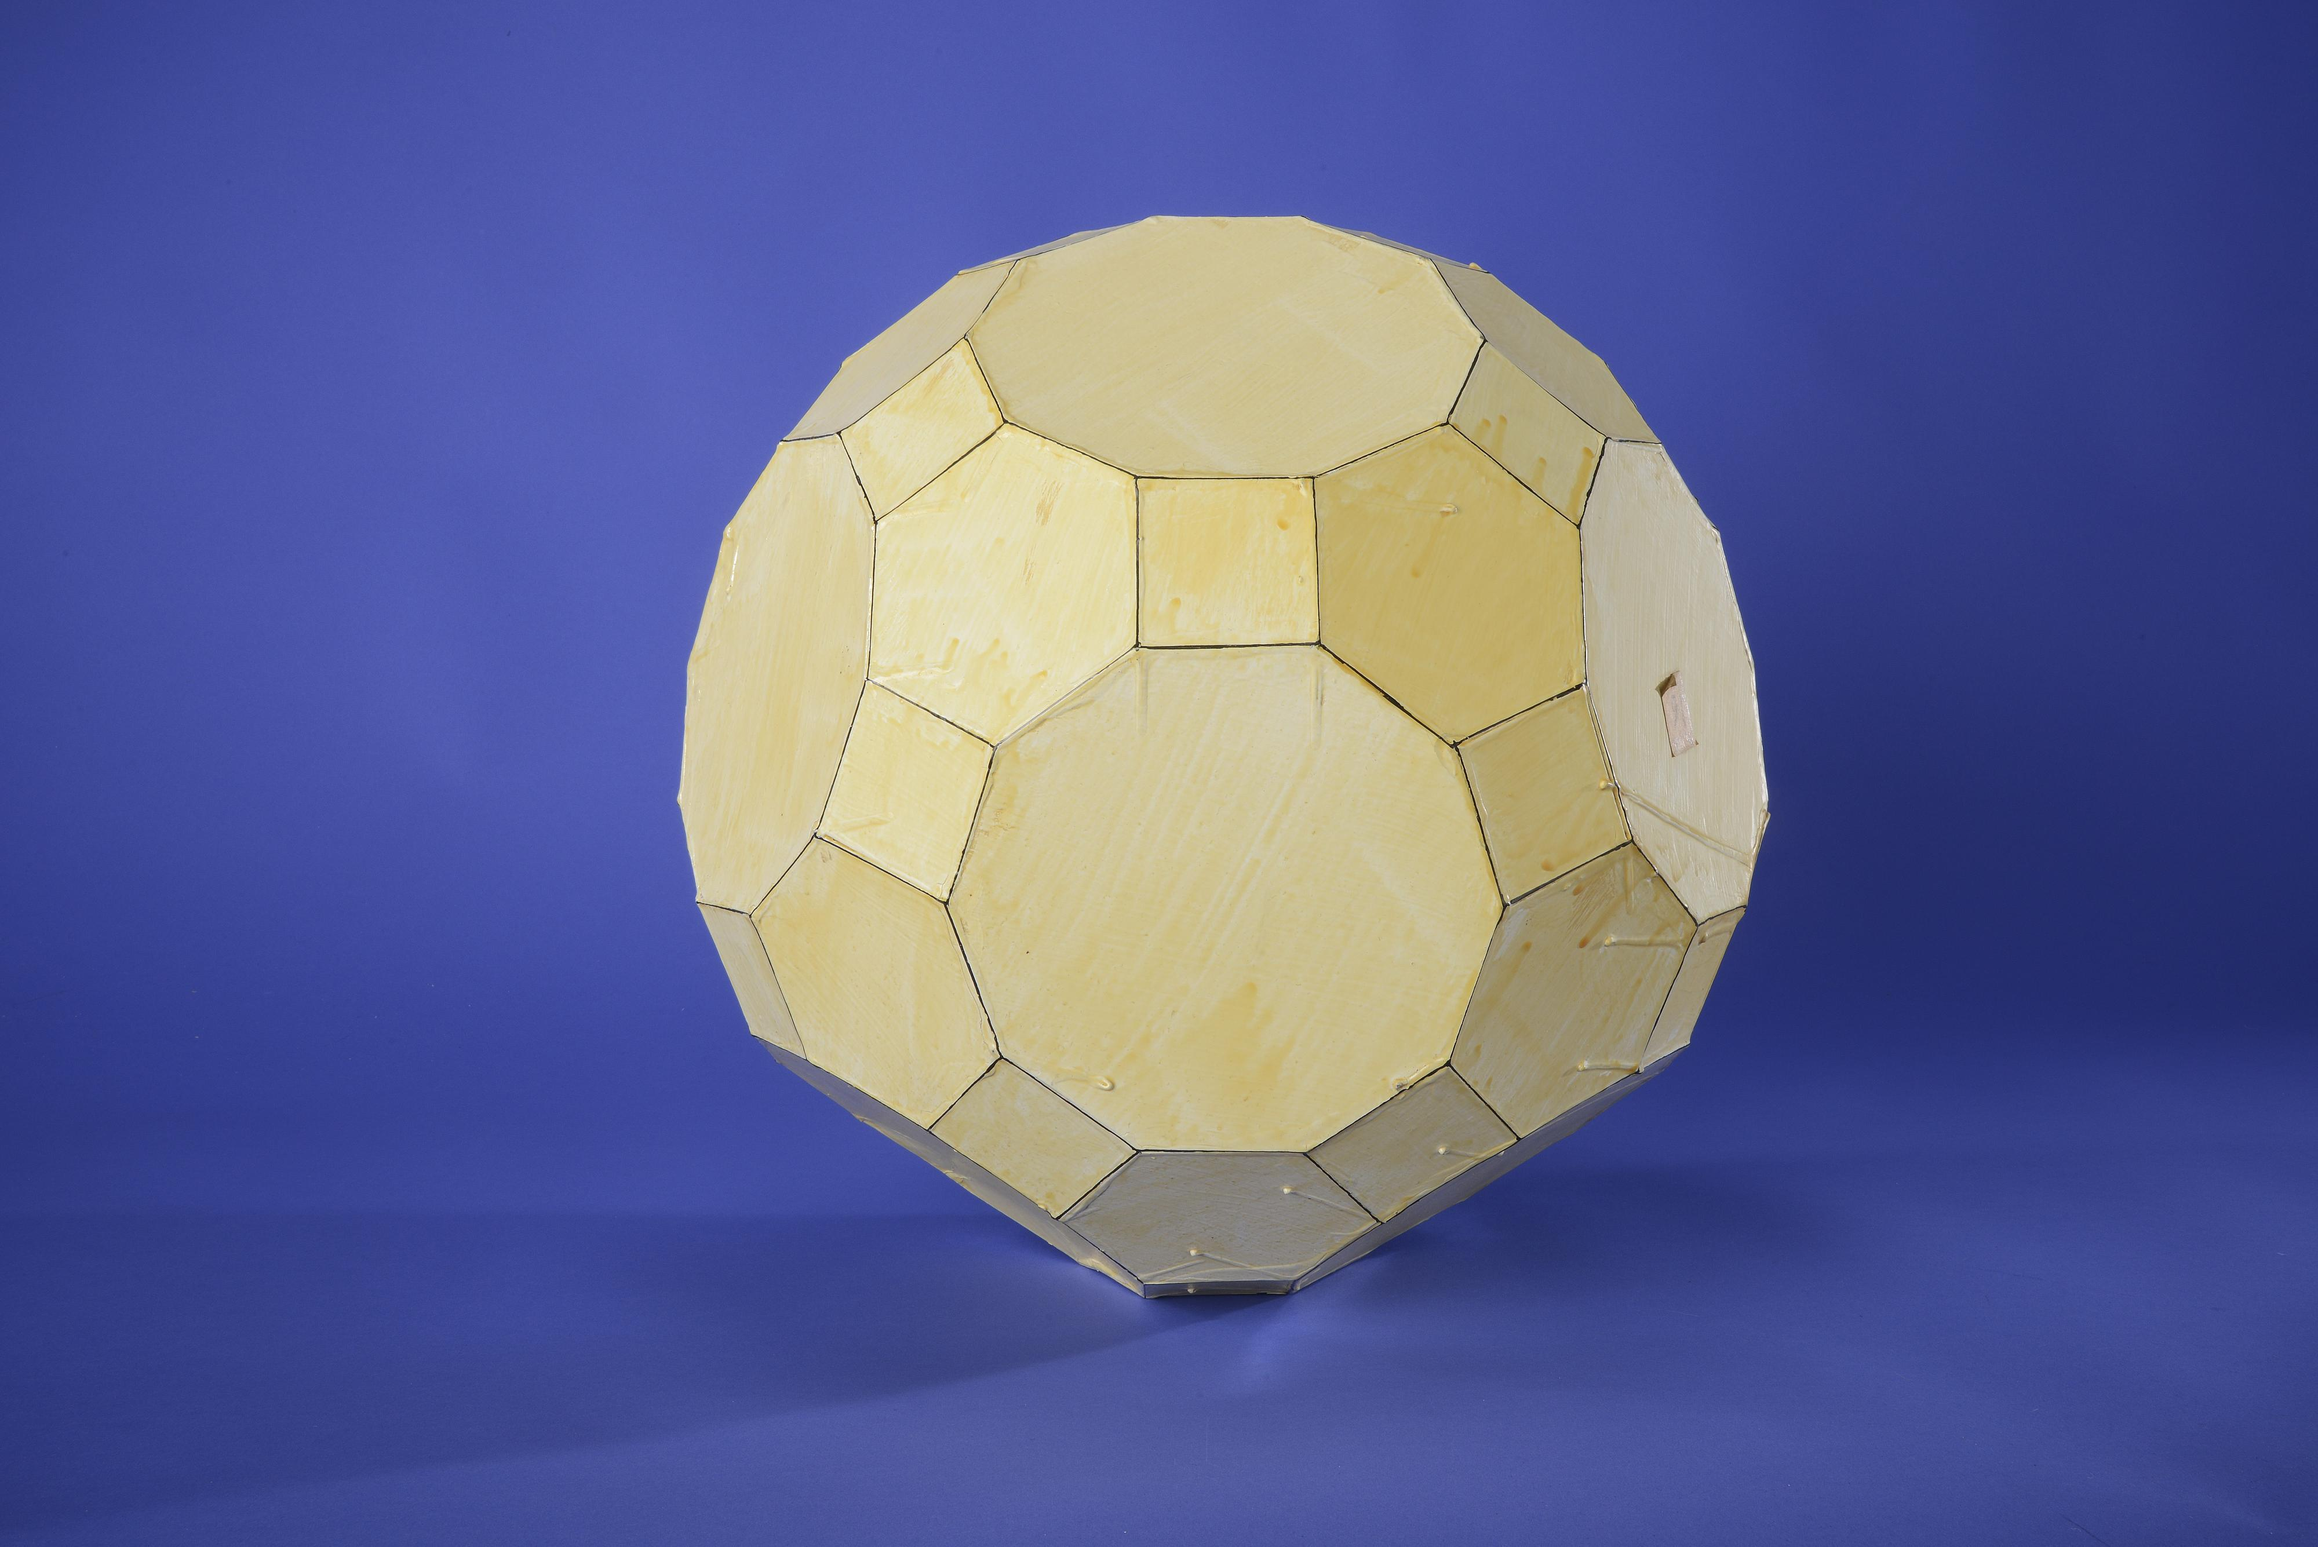
A non-uniform polyhedron can have different geometric structures. Some have irregular polygonal faces; others have entirely regular faces but lack vertex transitivity.

Mathematical Properties
# Source: AI Source: Provided by: [Data Path: Persons Table -> ID Column: 1, Name_En Column: Motasem Essam] -> From: [ChatGPT] on [7/25/2026]
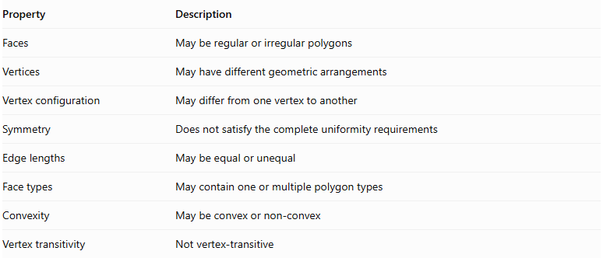
Property | Description
Faces | May be regular or irregular polygons
Vertices | May have different geometric arrangements
Vertex configuration | May differ from one vertex to another
Symmetry | Does not satisfy the complete uniformity requirements
Edge lengths | May be equal or unequal
Face types | May contain one or multiple polygon types
Convexity | May be convex or non-convex
Vertex transitivity | Not vertex-transitive
Important distinction: Having identical vertex configurations does not always make a polyhedron uniform. The vertices must also be geometrically equivalent under the symmetries of the solid. The elongated Square Gyrobicupola (J37) is a notable example: it has the same vertex arrangement at every vertex but is not vertex-transitive.

Types of Non-Uniform Polyhedra

Non-Uniform Regular-Faced Polyhedra
# Source: AI Source: Provided by: [Data Path: Persons Table -> ID Column: 1, Name_En Column: Motasem Essam] -> From: [ChatGPT] on [7/25/2026]
These polyhedra have regular polygonal faces, but their vertices are not all geometrically equivalent.
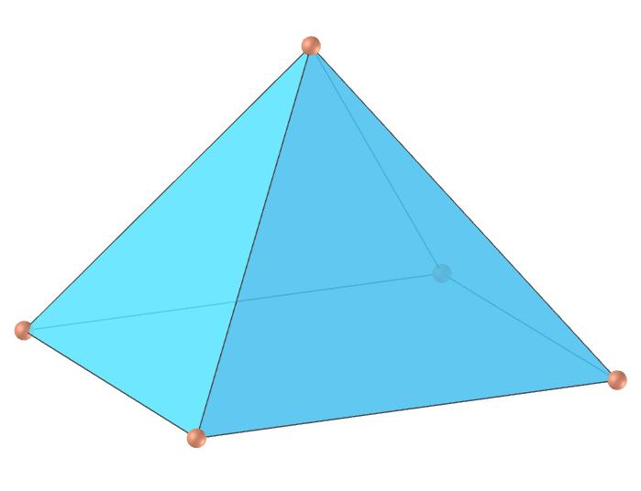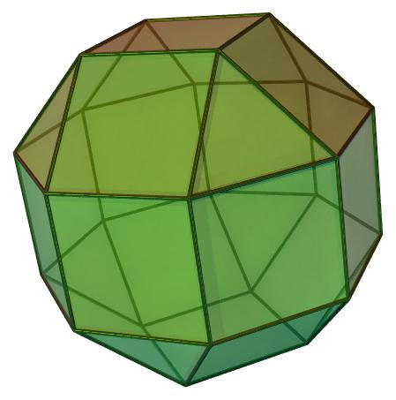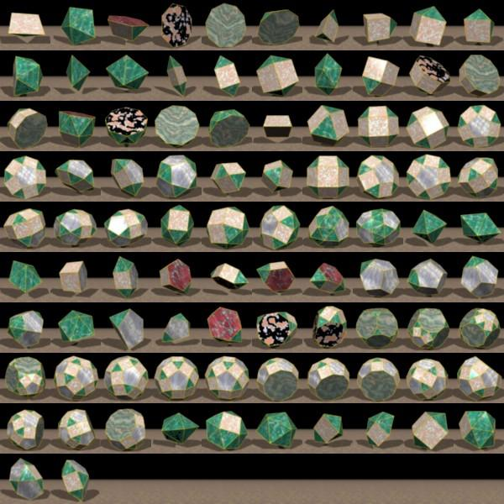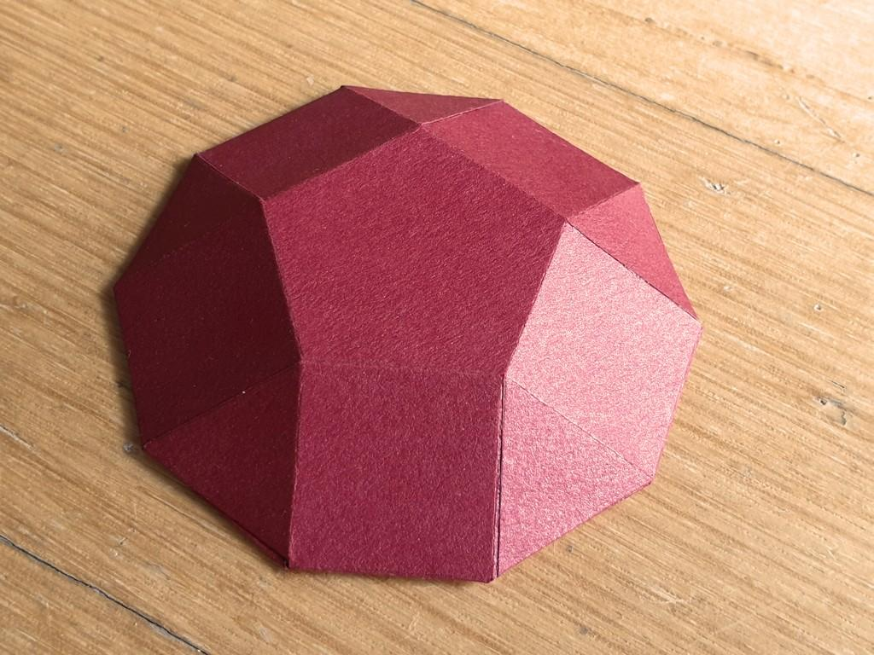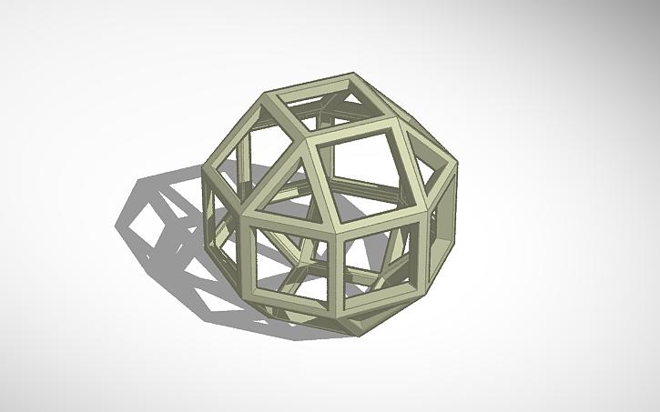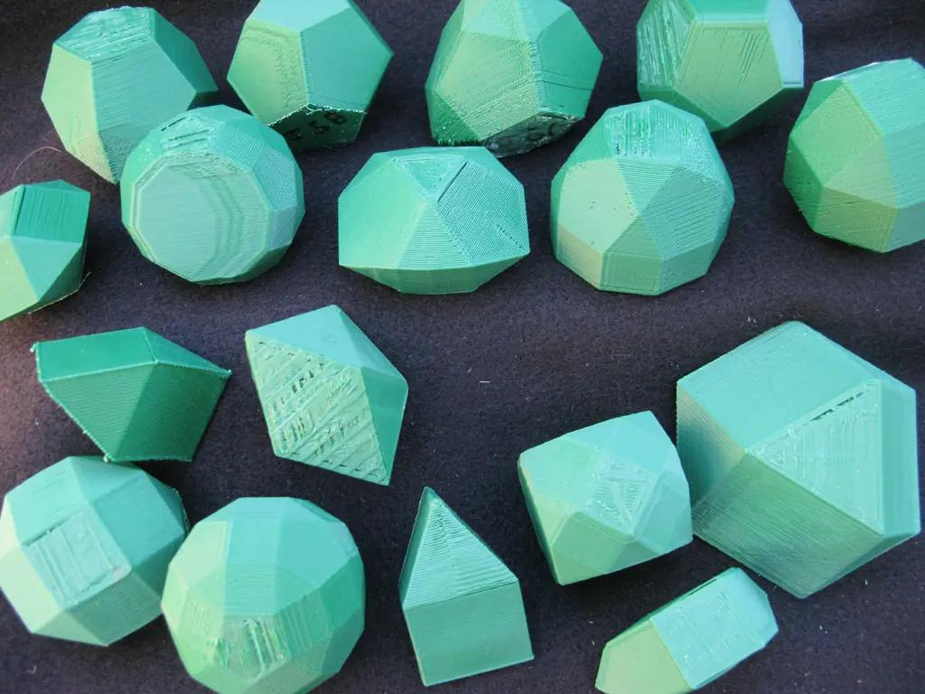

A. Johnson Solids
# Source: AI Source: Provided by: [Data Path: Persons Table -> ID Column: 1, Name_En Column: Motasem Essam] -> From: [ChatGPT] on [7/25/2026]
The 92 Johnson solids are convex polyhedra whose faces are regular polygons but which are not uniform polyhedra.
Examples:
- Square Pyramid (J1)
- Pentagonal Pyramid (J2)
- Triangular Cupola (J3)
- Square Cupola (J4)
- Pentagonal Cupola (J5)
- Triangular Rotunda (J6)
- Square Gyrobicupola (J29)
- Pentagonal Gyrobicupola (J31)
- Elongated Square Gyrobicupola (J37)
Johnson solids include different vertex configurations and arrangements of regular faces.

B. Other Non-Uniform Regular-Faced Polyhedra
# Source: AI Source: Provided by: [Data Path: Persons Table -> ID Column: 1, Name_En Column: Motasem Essam] -> From: [ChatGPT] on [7/25/2026]
These include regular-faced convex polyhedra that are not necessarily members of the 92 Johnson solids, such as composite or assembled regular-faced polyhedra.
Examples include certain polyhedra formed by joining regular-faced solids along matching faces.

Non-Uniform Irregular-Faced Polyhedra
# Source: AI Source: Provided by: [Data Path: Persons Table -> ID Column: 1, Name_En Column: Motasem Essam] -> From: [ChatGPT] on [7/25/2026]
These polyhedra contain one or more faces that are not regular polygons.
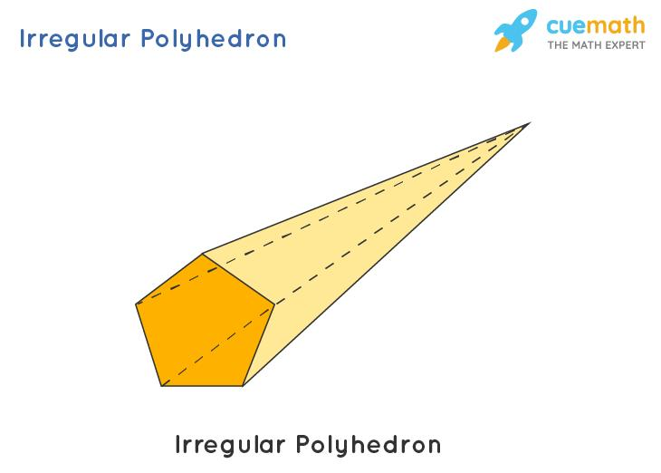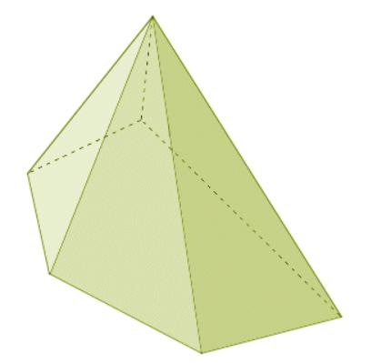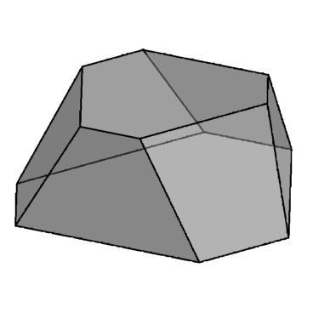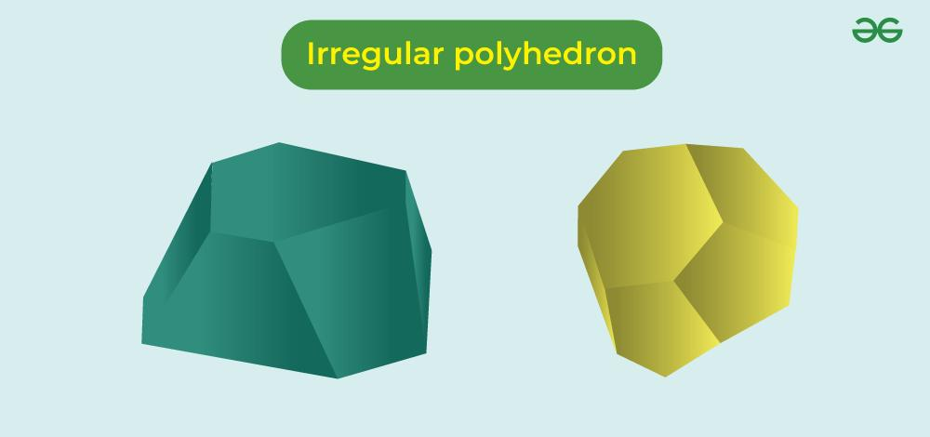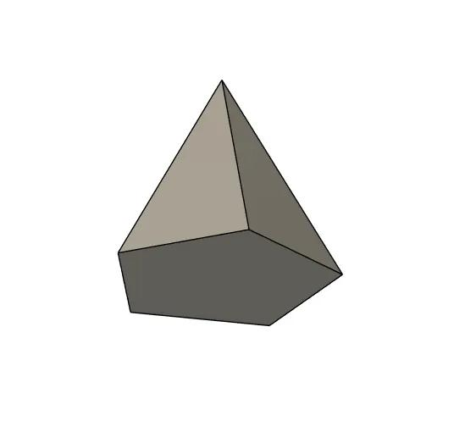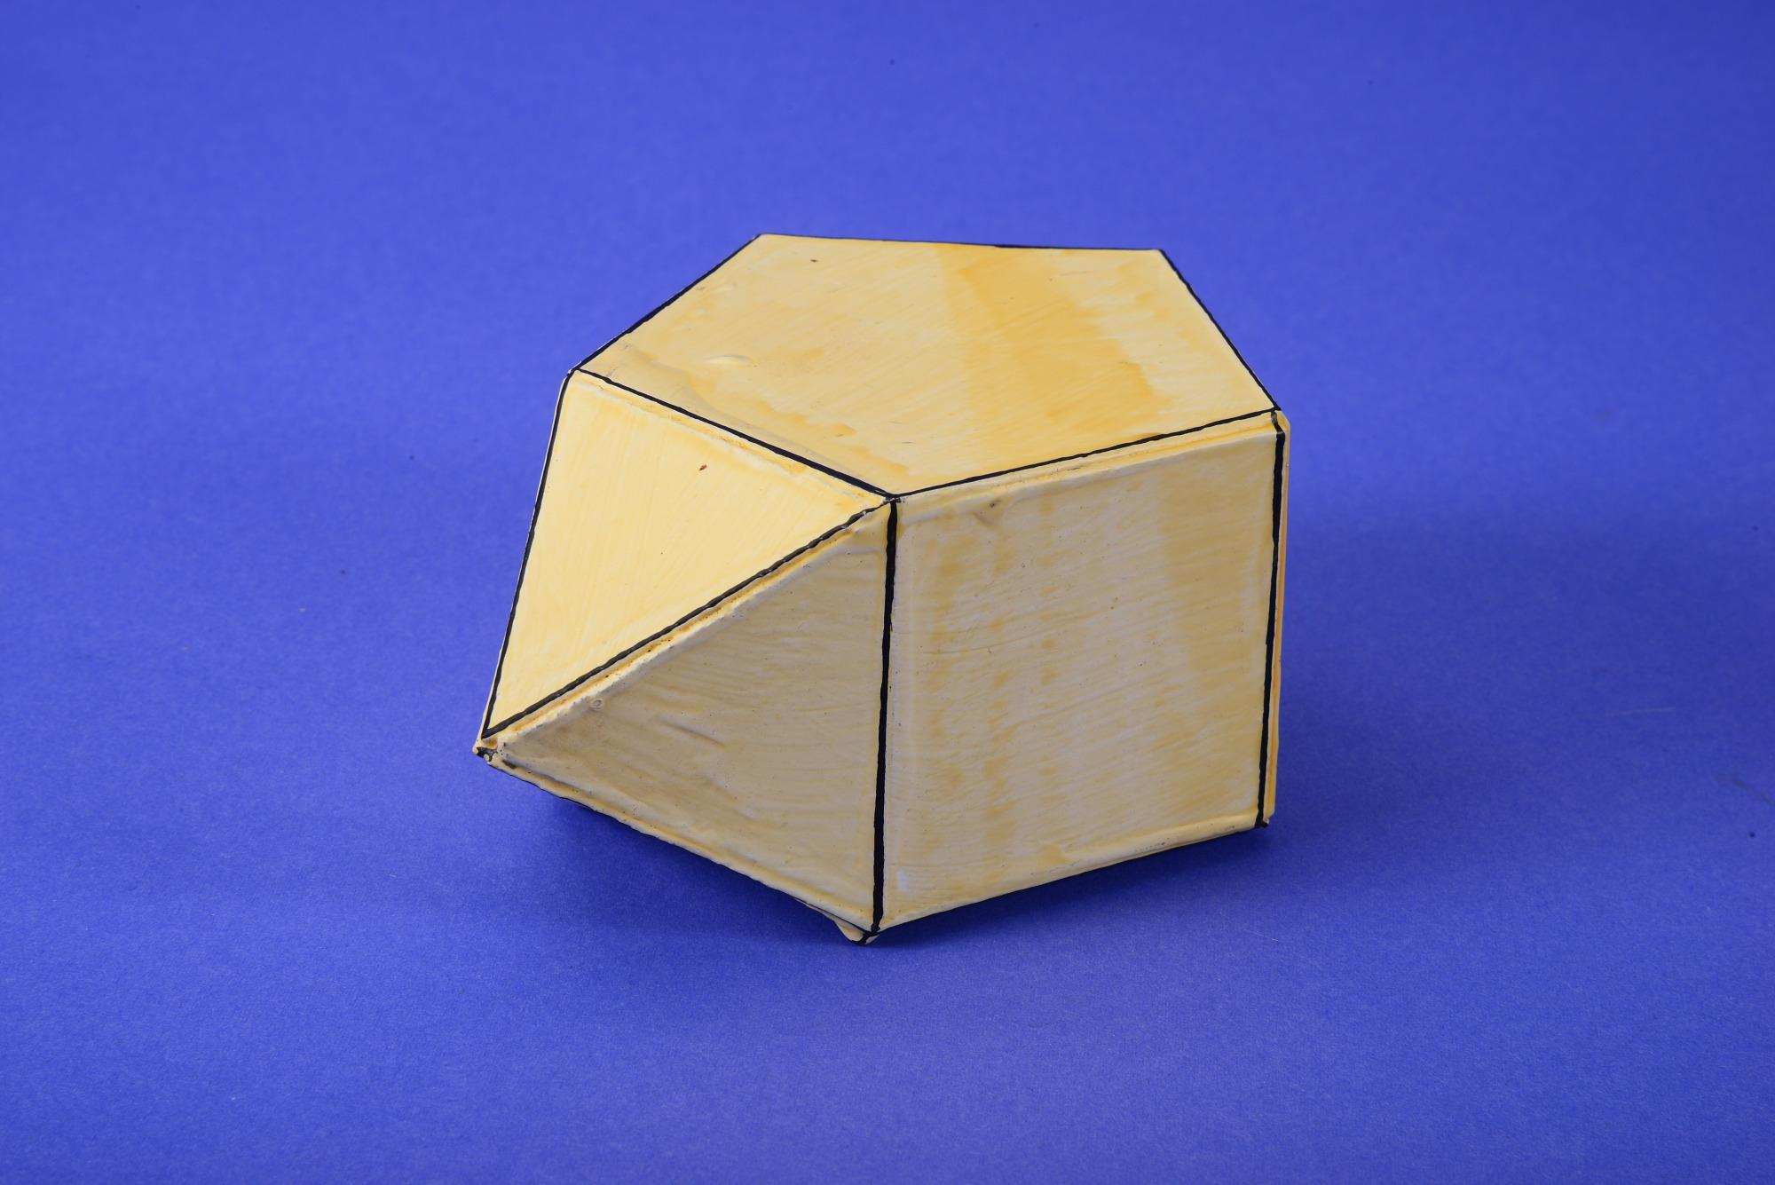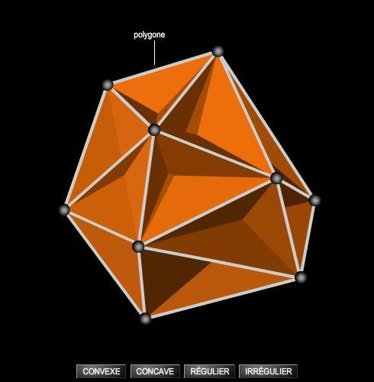

A. Irregular Prisms
# Source: AI Source: Provided by: [Data Path: Persons Table -> ID Column: 1, Name_En Column: Motasem Essam] -> From: [ChatGPT] on [7/25/2026]
Prism-like polyhedra whose bases or lateral faces are not all regular polygons.
Examples:
- Irregular Triangular Prism
- Irregular Quadrilateral Prism
- Irregular Pentagonal Prism
- Irregular N-gonal Prism

B. Irregular Pyramids
# Source: AI Source: Provided by: [Data Path: Persons Table -> ID Column: 1, Name_En Column: Motasem Essam] -> From: [ChatGPT] on [7/25/2026]
Pyramids with irregular polygonal bases, unequal lateral edges, or non-identical triangular side faces.
Examples:
- Irregular Triangular Pyramid
- Irregular Square Pyramid
- Irregular Pentagonal Pyramid
- Irregular N-gonal Pyramid

C. Irregular Polyhedra with Mixed Faces
# Source: AI Source: Provided by: [Data Path: Persons Table -> ID Column: 1, Name_En Column: Motasem Essam] -> From: [ChatGPT] on [7/25/2026]
Polyhedra containing different irregular polygonal face shapes.
Examples:
- Polyhedra with irregular triangular and quadrilateral faces.
- Polyhedra with irregular pentagonal and hexagonal faces.
- Polyhedra with mixed regular and irregular faces.

Non-Uniform Non-Convex Polyhedra
# Source: AI Source: Provided by: [Data Path: Persons Table -> ID Column: 1, Name_En Column: Motasem Essam] -> From: [ChatGPT] on [7/25/2026]
These are non-convex polyhedra that do not satisfy the requirements of uniform polyhedra.
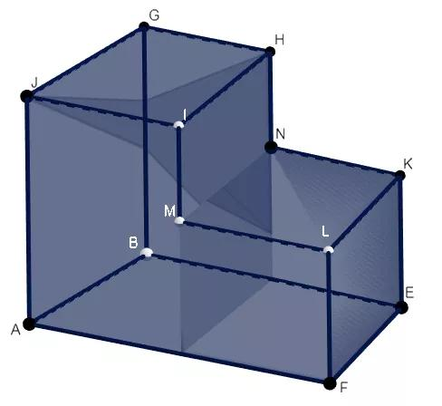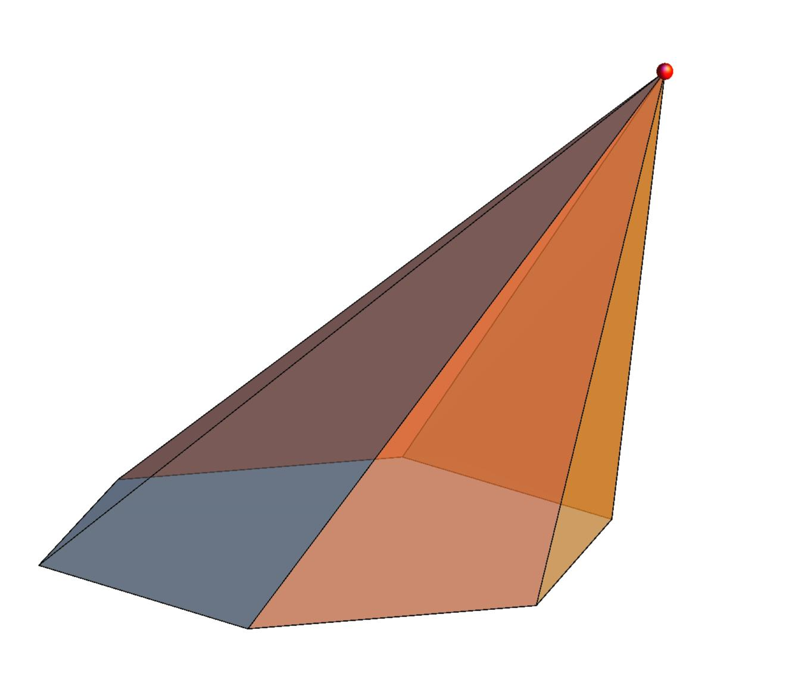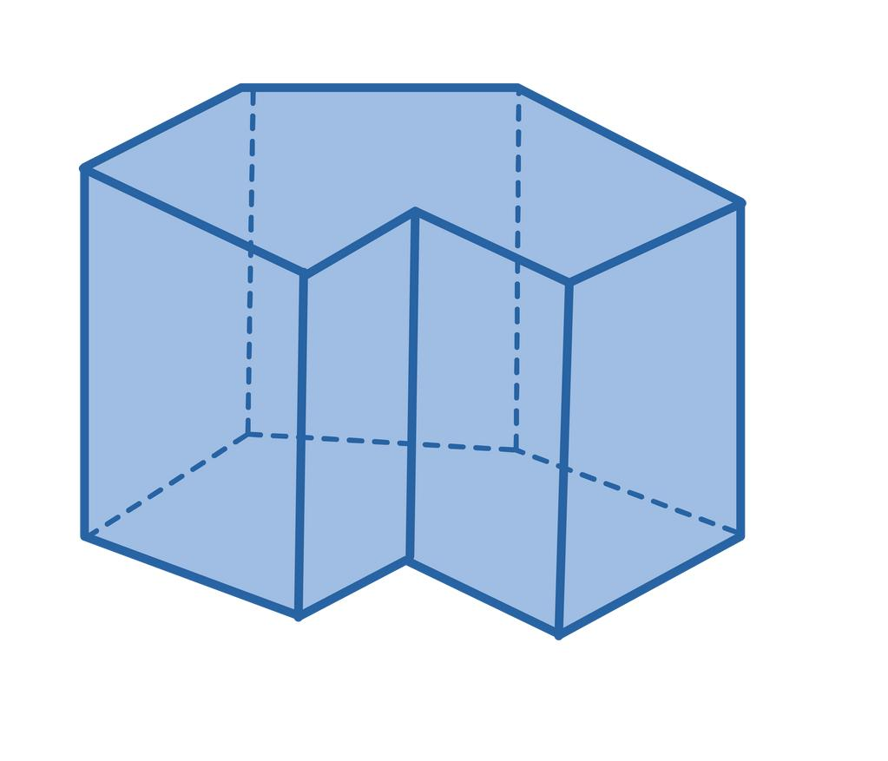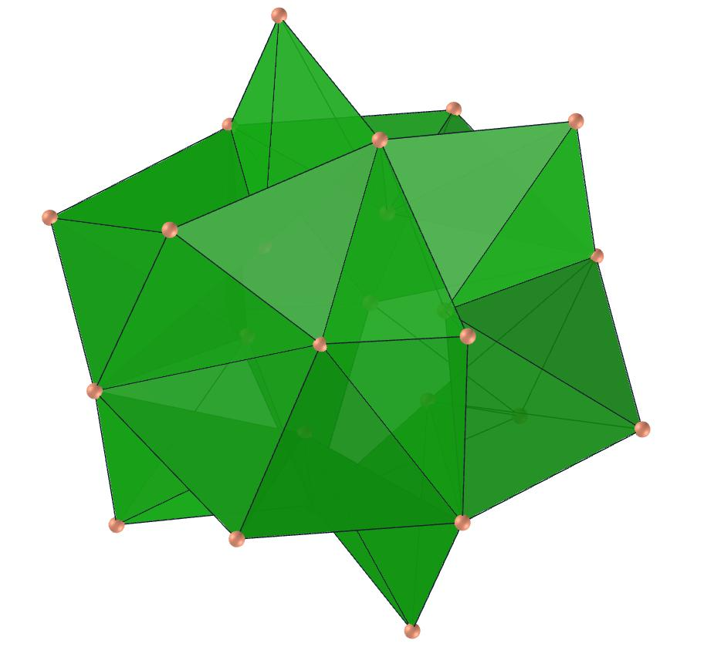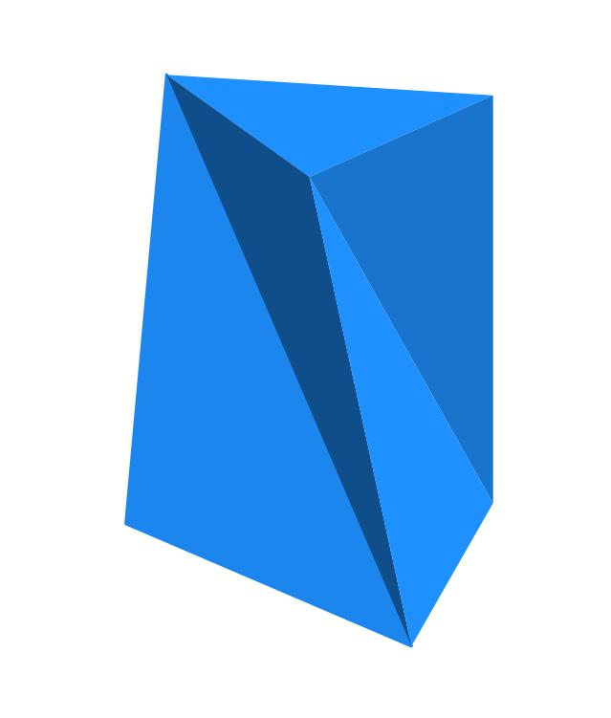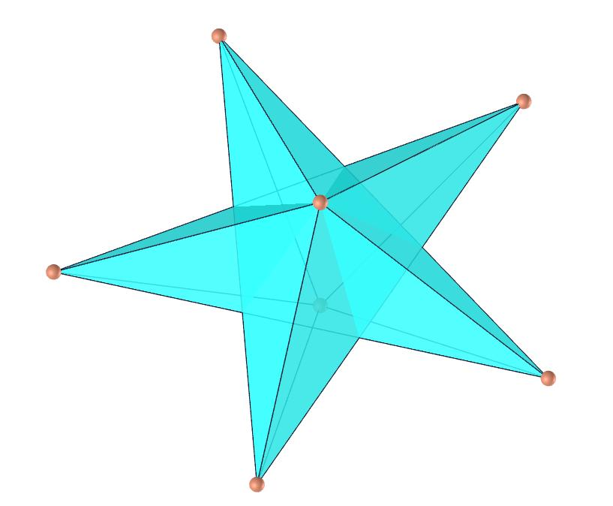
Examples include:
- Irregular Star-Like Polyhedra
- Concave Polyhedra
- Intersecting-Face Polyhedra
- Non-Convex Composite Polyhedra
These examples describe possible geometric structures, rather than a standardized mathematical family.

Geometric Characteristics
# Source: AI Source: Provided by: [Data Path: Persons Table -> ID Column: 1, Name_En Column: Motasem Essam] -> From: [ChatGPT] on [7/25/2026]
- Face irregularity: Faces may have unequal sides or angles.
- Vertex variation: Different vertices may have different arrangements of faces.
- Unequal edges: Edge lengths may vary throughout the solid.
- Multiple face types: A solid may contain different regular or irregular polygons.
- Symmetry: A non-uniform polyhedron lacks vertex transitivity.
- Convexity: It may be convex or non-convex.
- Construction: It may be formed through augmentation, truncation, joining, deformation, or other geometric operations.

Mathematical Classification
# Source: AI Source: Provided by: [Data Path: Persons Table -> ID Column: 1, Name_En Column: Motasem Essam] -> From: [ChatGPT] on [7/25/2026]
Non-uniform polyhedra do not have a single universal classification or fixed number. They can be described using several independent geometric properties.
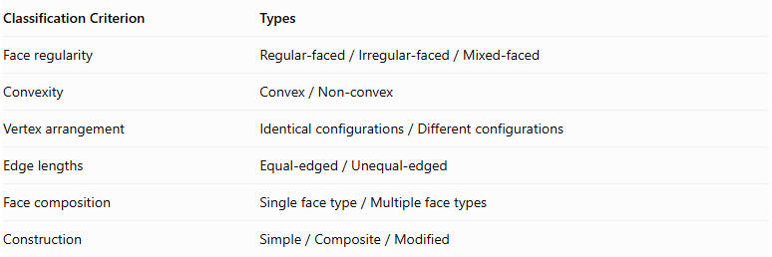
Classification Criterion | Types
Face regularity | $$Regular-faced/Irregular-faced/Mixed-faced$$
Convexity | $$Convex/Non-convex$$
Vertex arrangement | $$Identicalconfigurations/Differentconfigurations$$
Edge lengths | $$Equal-edged/Unequal-edged$$
Face composition | $$Singlefacetype/Multiplefacetypes$$
Construction | $$Simple/Composite/Modified$$
These categories can overlap. For example, a polyhedron can be convex, regular-faced, equal-edged, and still non-uniform because its vertices are not geometrically equivalent.

Uniform vs. Non-Uniform Polyhedra
# Source: AI Source: Provided by: [Data Path: Persons Table -> ID Column: 1, Name_En Column: Motasem Essam] -> From: [ChatGPT] on [7/25/2026]
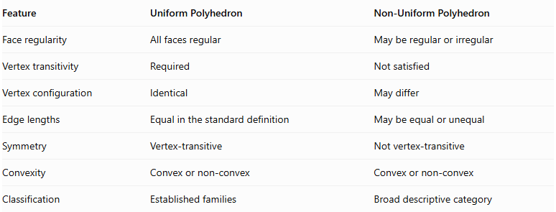
Feature | Uniform Polyhedron | Non-Uniform Polyhedron
Face regularity | All faces regular | May be regular or irregular
Vertex transitivity | Required | Not satisfied
Vertex configuration | Identical | May differ
Edge lengths | Equal in the standard definition | May be equal or unequal
Symmetry | Vertex-transitive | Not vertex-transitive
Convexity | Convex or non-convex | Convex or non-convex
Classification | Established families | Broad descriptive category

Related Geometric Solids
# Source: AI Source: Provided by: [Data Path: Persons Table -> ID Column: 1, Name_En Column: Motasem Essam] -> From: [ChatGPT] on [7/25/2026]
- Johnson Solids: Convex non-uniform polyhedra with regular polygonal faces.
- Irregular Polyhedra: Polyhedra containing irregular polygonal faces.
- Composite Polyhedra: Polyhedra formed by combining two or more geometric solids.
- Concave Polyhedra: Polyhedra with inward-facing regions.
- Star Polyhedra: Polyhedra with star-shaped geometric structures; some are uniform, while others are non-uniform.
- Uniform Polyhedra: The contrasting category, characterized by regular faces and vertex transitivity.

Main Classification
# Source: AI Source: Provided by: [Data Path: Persons Table -> ID Column: 1, Name_En Column: Motasem Essam] -> From: [ChatGPT] on [7/25/2026]
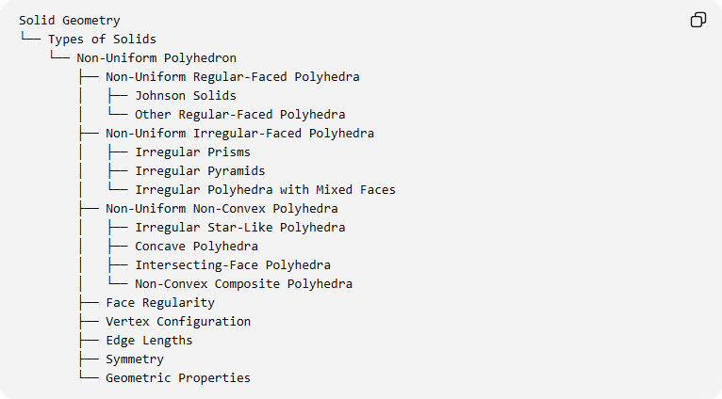
Solid Geometry
└── Types of Solids
└── Non-Uniform Polyhedron
├── Non-Uniform Regular-Faced Polyhedra
│ ├── Johnson Solids
│ └── Other Regular-Faced Polyhedra
├── Non-Uniform Irregular-Faced Polyhedra
│ ├── Irregular Prisms
│ ├── Irregular Pyramids
│ └── Irregular Polyhedra with Mixed Faces
├── Non-Uniform Non-Convex Polyhedra
│ ├── Irregular Star-Like Polyhedra
│ ├── Concave Polyhedra
│ ├── Intersecting-Face Polyhedra
│ └── Non-Convex Composite Polyhedra
├── Face Regularity
├── Vertex Configuration
├── Edge Lengths
├── Symmetry
└── Geometric Properties

Key Points
# Source: AI Source: Provided by: [Data Path: Persons Table -> ID Column: 1, Name_En Column: Motasem Essam] -> From: [ChatGPT] on [7/25/2026]
- A non-uniform polyhedron is a polyhedron that is not vertex-transitive.
- Its faces may be regular, irregular, or a mixture of both.
- Its vertices may have different configurations.
- Its edges may have equal or unequal lengths.
- It may be convex or non-convex.
- The 92 Johnson solids are an important family of convex non-uniform regular-faced polyhedra.
- Non-uniform polyhedra do not form a finite, universally enumerated family.

Conclusion
# Source: AI Source: Provided by: [Data Path: Persons Table -> ID Column: 1, Name_En Column: Motasem Essam] -> From: [ChatGPT] on [7/25/2026]
A Non-Uniform Polyhedron is a broad classification of polyhedra that lack vertex transitivity. It includes regular-faced solids such as Johnson solids, irregular-faced polyhedra, and non-convex polyhedra that do not satisfy the uniformity requirements.
Taxonomy note: Keep Johnson Solids as a specific subgroup of non-uniform regular-faced polyhedra. Do not classify every non-uniform polyhedron as a Johnson solid.

